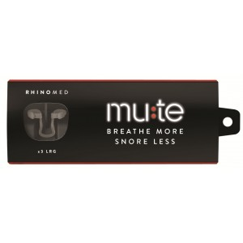
http://mutesnoring.com/

Mute is a nasal respiratory technology device designed to increase air flow through your nose during sleep by gently opening your airways.

Price: $29.89

Details
Mute is a nasal respiratory technology device designed to increase air flow through your nose during sleep by gently opening your airways. By breathing more freely through the nose, Mute may reduce the effects of nighttime nasal congestion and may reduce snoring.

Dosage
Mute is only suited for positioning inside the nose. Each device can be used up to 7 times.

Storage
To maintain optimal performance of Mute, store at room temperature and avoid prolonged exposure to direct sunlight.

Warnings
Keep out of reach of children, contains small parts. Mute is not suitable for use by children under the age of 12. Always read the label. Use only as directed.

